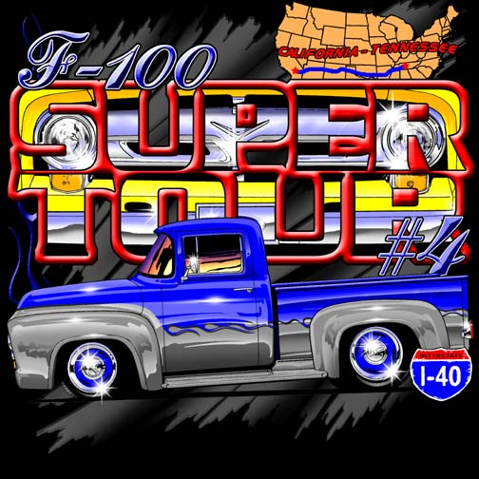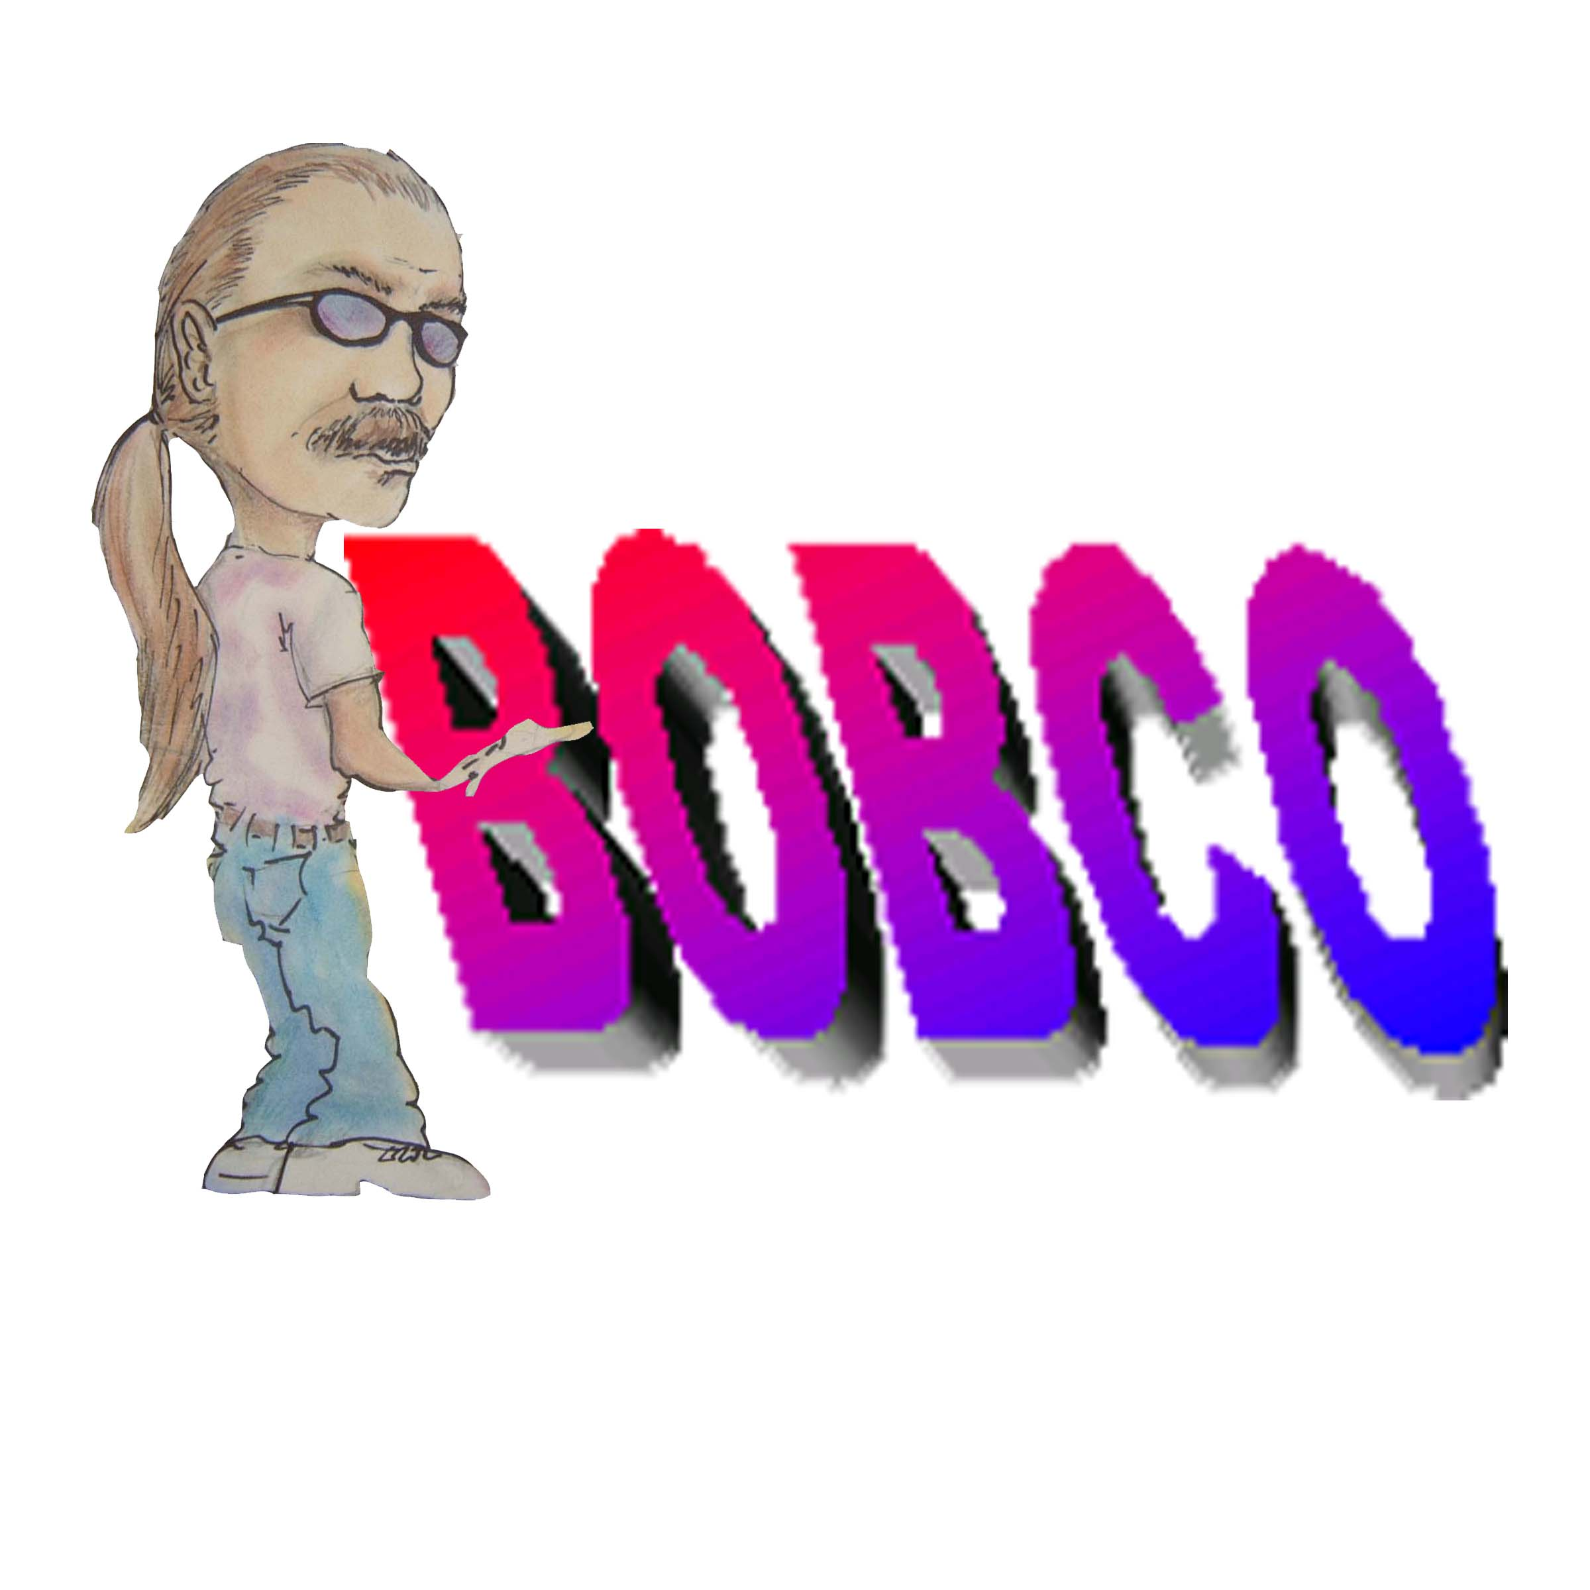

Super Tour Kick Off Party
Fun Raiser for
Progeria Research

On behalf of Bob, Shirl, And the Whole Carvajal Family, and Bill n Bonnie Lee, we would like to thank everyone for your support and for your donations to the Progeria Research Foundation. Without your support and commitment we wouldn’t have been able to pull this off.
Dan n Cathy Cangro of Orange County Pickups Limited own Vintage Vinyl Mobile DJ service and they donated their time and played music the whole day.
Members of OC helped us park trucks and we’re looking for things they could help with. Thanks to all that helped.
We didn’t get an accurate count on trucks that we’re there but we had a full house. If you didn’t want to look at old Ford Trucks this was not the place to be.
Now for the meat and potatoes of the Kick off Party. With all the support and donations from you the participants, we hit our goal and in fact more than doubled it. As we said from the start 100% of all proceeds will go to the Progeria Research Foundation. The food was covered by Bob n Shirl, Bonnie n I. Now are you ready??? We raised $22,565 for a 6 hour truck show. We will be presenting the funds to Sam and Terry Foose sometime this week at Bobco’s Shop. Terry Foose is the president of Progeria Research So. Calif. Chapter.
On behalf of all that were involved in this fund raiser we would like to thank all of you for the support and your donations that helped us reach this goal. As for myself I am very proud to be a member of Pickups Limited that has once again came thru for a good cause.
Bob, Shirl, Bonnie, Bill

