Volunteer Translator Application

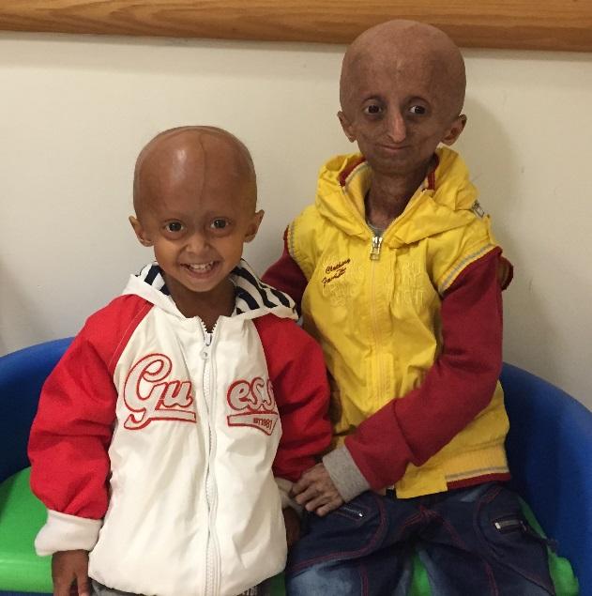

Together we will find the cure!

The Progeria Research Foundation, Inc. Tel: (978) 535-2594
PO Box 3453 Fax: (978) 535-5849
Peabody, MA 01961-3453 www.progeriaresearch.org

Please help us learn more about you and your volunteer interests. Your answers to the following questions will help us determine how your skills, interests, and availability match our translation needs Thank you for your time.

GETTING TO KNOW YOU

Name ____________________________________________ Date ________________

Address

Phone(Home)_______________(Work/cell)_______________ Fax ________________

E-mail Address _____________________ Date available _______________________

Please list and describe:

Language(s) available to translate _________________________________________
Level of fluency in language ______________________________________________
Past volunteer/translator experience ________________________________________
______________________________________________________________________
______________________________________________________________________
Work experience ________________________________________________________
______________________________________________________________________
______________________________________________________________________
Education (formal or other, please include computer skills) _______________________
______________________________________________________________________
______________________________________________________________________
Hobbies/Interests _______________________________________________________
______________________________________________________________________

Please provide two personal references (for students)

Name: _________________Relationship: _______________ Phone: __________
Name: _________________Relationship: _______________ Phone: __________

What prompted you to contact The Progeria Research Foundation?(check all that apply)
- Web site
- Staff – who? ________________
- Television program – which one? ___________________
- Another volunteer – who? _____________________
- Personal interest on behalf of a family member or friend – who? ______________

- Newspaper/Magazine article – which one? (name, issue) ____________________
- An event – which one? _______________________________________________

DEFINING YOUR COMMITMENT
- 1-3 hours a week | - 1-3 months
- 4-6 hours a week | - 4-6 months
- 7-10 hours a week | - 6-12 months
- more (please explain) _______________________________ | - more (please explain) _______________________________

MATCHING YOUR NEEDS WITH OURS

Please describe why you want to volunteer your time and talent with the Progeria Research Foundation.

Is there anything else you wish to add that you feel may be helpful to us and to you regarding your volunteering opportunity with The Progeria Research Foundation?

Is there any additional information about our work that we can mail or fax to you?

We sincerely appreciate your interest.
Thank you for taking the time to complete our questionnaire.

The Progeria Research Foundation, Inc. Tel: (978) 535-2594
PO Box 3453 Fax: (978) 535-5849
Peabody, MA 01961-3453 www.progeriaresearch.org

Contact information:
Kyra Johnson, Clinical Trial Coordinator/Family Liaison
Email: translation@progeriaresearch.org

