Volunteer Translator Application

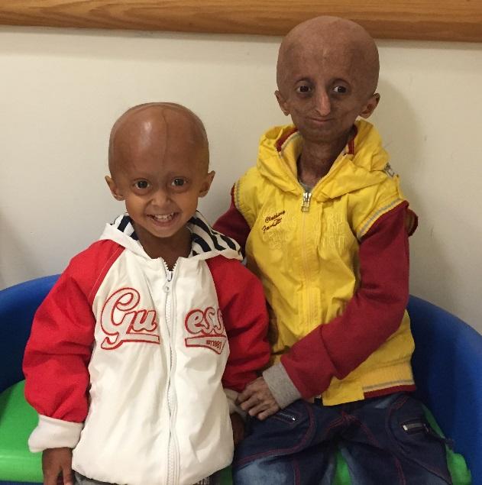

Together we will find the cure!

The Progeria Research Foundation, Inc. Tel: (978) 535-2594
PO Box 3453 Fax: (978) 535-5849
Peabody, MA 01961-3453 www.progeriaresearch.org

We are very excited by your interest in becoming a volunteer translator at The Progeria Research Foundation (PRF). We look forward to having you become part of the PRF Team. Please help us learn more about you and your volunteer interests. Your answers to the following questions will help us determine how your skills, interests, and availability match our translation needs Thank you for your time.

As a PRF volunteer translator, you may be exposed to or become aware of information that is confidential; that is, information that should not be shared or discussed with anyone other than those working with or assisting you with your translations for PRF.

Examples of confidential information includes any and all information about the children and families participating in various PRF programs or clinical trials, including and not limited to names, addresses, diagnoses, treatment, personal life and status with PRF.

Certain information about the business practices of PRF is also confidential. This includes information about our donors, volunteers and grant recipients, and information related to research or clinical trials conducted by those affiliated with or funded by PRF.

Should you have a question as to whether certain information is confidential, please consult with Meryl Fink, Executive Director, who will provide you with the necessary guidance.

By returning this application you acknowledge your understanding and agreement to maintain the information described in a confidential manner.

GETTING TO KNOW YOU

Name ____________________________________________ Date ________________

Address

Phone(Home)_______________(Work/cell)_______________ Fax ________________

E-mail Address _____________________ Date available _______________________

Please list and describe:

Language(s) available to translate _________________________________________
Level of fluency in language ______________________________________________
Past volunteer/translator experience ________________________________________
______________________________________________________________________
______________________________________________________________________
Work experience ________________________________________________________
______________________________________________________________________
______________________________________________________________________
Education (formal or other, please include computer skills) _______________________
______________________________________________________________________
______________________________________________________________________
Hobbies/Interests _______________________________________________________
______________________________________________________________________

Please provide two personal references (for students)

Name: _________________Relationship: _______________ Phone: __________
Name: _________________Relationship: _______________ Phone: __________

What prompted you to contact The Progeria Research Foundation?(check all that apply)
- Web site
- Staff – who? ________________
- Television program – which one? ___________________
- Another volunteer – who? _____________________
- Personal interest on behalf of a family member or friend – who? ______________

- Newspaper/Magazine article – which one? (name, issue) ____________________
- An event – which one? _______________________________________________

DEFINING YOUR COMMITMENT
- 1-3 hours a week | - 1-3 months
- 4-6 hours a week | - 4-6 months
- 7-10 hours a week | - 6-12 months
- more (please explain) _______________________________ | - more (please explain) _______________________________

MATCHING YOUR NEEDS WITH OURS

Please describe why you want to volunteer your time and talent with the Progeria Research Foundation.

Is there anything else you wish to add that you feel may be helpful to us and to you regarding your volunteering opportunity with The Progeria Research Foundation?

Is there any additional information about our work that we can mail or fax to you?

We sincerely appreciate your interest.
Thank you for taking the time to complete our questionnaire.

The Progeria Research Foundation, Inc. Tel: (978) 535-2594
PO Box 3453 Fax: (978) 535-5849
Peabody, MA 01961-3453 www.progeriaresearch.org

Contact information:
Gina Incrovato, Clinical Trial Coordinator/Family Liaison
Email: translation@progeriaresearch.org

