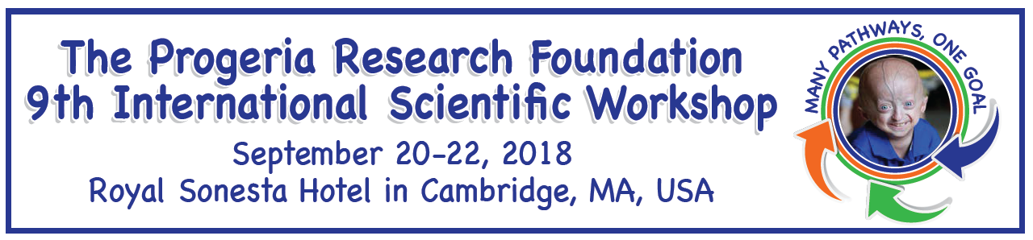

Speaker Abstract
Due by August 24, 2018
Please do not adjust margins, as all information is to be provided in the format below.

Title:

Author(s):

Institution:

