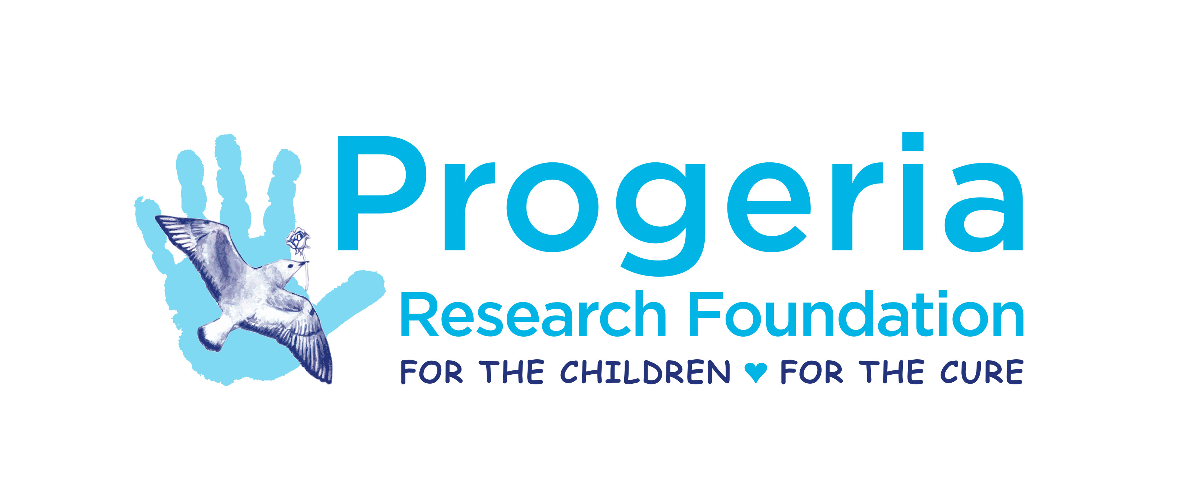

Grant Agreement Form
(To be signed along with the PRF Patent, Intellectual Property and
Technology Transfer Policy after a grant is awarded)

- In accepting a Grant from The Progeria Research Foundation, Inc. (PRF), the Principal Investigator (“PI”) and the grantee institution (“Institution”) assume an obligation to expend grant funds for the research purposes set forth in the application, and to affirm that there is no duplicate funding for these purposes, unless otherwise disclosed. The PI and Institution will promptly notify PRF of activation or funding of any application for support to which PRF support is alternative.

- PRF requires the signed Grant Agreement Form and Intellectual Property and Technology Transfer Policy to be returned no later than 30 days after the receipt of the award letter. Projects must be started within 3 months of the award. The PI will decide the month and choose the first day of that month as the project start date. The start date is the earliest that funds may be obligated or expended. The termination date of the award will be the date indicated in the original notification letter or the date provided by an authorized extension. The termination date is the latest that funds may be expended except to liquidate authorized obligations.

- The Institution is obligated to administer the grant in accordance with the regulations and policies governing the grant programs of PRF or, where not specified, consistent with the policies and practices of the Institution.

- PRF requires a detailed accounting of all funds expended to be submitted every 12 months, or more frequently at the discretion of PRF (with thirty days’ notice), and a final accounting and progress report within 60 days of the end of the project. The fiscal officer of the Institution will provide and sign such Expenditures/Financial Reports, co-signed by the PI. Financial Reports should include detailed, budget-to-actual expense amounts. See Budget to Actual form at http://www.progeriaresearch.org/grant_application.html. The fiscal officer of the Institution will agree to make available to representatives of PRF, following due notice, accounting records of disbursements made from PRF’s grant funds.

- Any funds not used in the manner specified in the application must be returned to PRF, and any budget change that is greater than 10% of any one budget category must be submitted in writing for approval by the PRF Medical Research Committee (MRC), such approval not to be unreasonably denied. Principal Investigators may apply for an extension of time to use remaining funds at the end of the grant period. For multiple year grant awards, funds not used in one year will be available for use in the following year if written approval is obtained from PRF.

- Along with the Financial Reports listed above, every six months during the grant period, or more frequently at the discretion of PRF (with thirty days’ notice), the PI shall also submit a Progress Report/Annual report of his/her technical accomplishments.

Progress reports (interim and final) shall include the following elements:
- Address each aim, semi-annual milestones and include all relevant data, etc.
Define original aims and corresponding timelines in bullet-point format, then include progress for each.
- Problems/pitfalls
- Change in direction, if any (must be approved in writing by MRC)
- Plans for the coming six months (for interim reports only)

A Template for Interim and Final Technical Progress Reports is found at http://www.progeriaresearch.org/grant_application.html

- Quarterly payments will be withheld pending receipt and approval of all required reports due prior to the payment date. The final grant payment will be made upon receipt and approval of all required reports.

Grant payments will be forfeited if interim progress and/or financial reports are received later than two weeks after the specified deadline (unless an extension has been approved prior to the deadline), or if the progress is deemed inadequate by PRF. If both the final financial and technical reports are not received within the 60 day deadline, the final grant payment will be forfeited unless special extension has been granted by PRF in advance of the due date.

- Grant Advisors will meet with grantees (via phone or teleconference) within one month of report submission at months 6, 12, and 18. The purpose of these advisory meetings is to discuss progress, pitfalls, and changes in project direction, and to provide assistance in any way possible to facilitate the achievement of the project aims. Should there be a change in direction from the original aims and milestones to the grant proposal, the PRF Medical Research Committee must be notified and approval from the committee will be required.

- In the final year or at the earliest date possible thereafter, the PI shall submit a list of articles published or accepted for publication, and a summary of the research results.

- In order to foster interactions among grantees and others interested in Progeria research, the PI will be required to present his/her work at each PRF workshop taking place during his/her funding period, including any approved no cost extension period. PRF workshops are held every other year. The grant budget should include funds to cover the travel costs to attend the workshops. The grantee agrees to attend the PRF workshops in their entirety and to present the PRF-funded research during the meetings. Though additional laboratory staff is welcome to attend and submit posters for presentation, attendance and oral presentation by the PI is mandatory.

- Results of research will be made freely available to the public through appropriate scientific channels and all publications will bear the statement: "THIS WORK WAS SUPPORTED BY GRANT #XXX FROM THE PROGERIA RESEARCH FOUNDATION.” The PI and Institution will not permit release of any publicity regarding the award or the research without advance clearance from PRF.

- If the research results are to be published, the PI shall provide PRF with advance written notice, no later than one week before publication, a PDF of the article and any press releases related thereto. PRF shall not disclose such information to the public until the article is published and embargo released, if required. PRF has discretion to permit shorter notice or require longer notice if circumstances warrant.

- Permission for a change in PI or Institution must be authorized by PRF in advance or the grant will terminate on the date the PI leaves or ceases to work at the Institution at which the grant was awarded.

- With regard to any and all research tools that are created in the course of a grant funded, in whole or in part, by PRF, including but not limited to constructs, antibodies and animal models for Progeria, such tools must be made freely available to PRF and any and all researchers who reasonably request it for the purposes of academic, non-commercial research. The creation of a mouse model, for example, shall be deposited by PI and Institution in a repository, such as The Jackson Laboratory (www.jax.org ) that will make the model available to the general research community.

The information regarding the availability of said tools shall be available through PRF’s website and any other means PRF deems reasonable and appropriate. These tools must be made available within 6 months of publication of results, or 6 months after the grant has ended, whichever comes first. The PI and Institution shall promptly provide to PRF the name and contact information of those requesting and receiving said research tools.

If the PI and Institution fail to make such research tools freely available as provided above, PI and the Institution shall return all research grant monies provided by PRF for the project for which this grant is given.
- Discoveries or inventions resulting from the Principal Investigator’s research, or to which the investigator is a party, and carried out during the tenure of the PRF Grant, will be subject to the current Patent, Intellectual Property and Technology Transfer Policy of PRF attached. Such policy may be amended from time to time. Amendments are posted on PRF’s web site.

- PRF endorses the principles of the Association of American Medical Colleges (AAMC) report, “The Maintenance of High Ethical Standards In The Conduct of Research."

- PRF does not fund scientific research that involves the use of human fetal tissue. With respect to human and animal experimentation, the Executive Officer of the sponsoring institution and the principal investigator affirm that:

  - The investigations which might involve human subjects have been endorsed by a committee on clinical investigation, or other clearly designated appropriate body, of the sponsoring institution.
  - Any research involving human subjects will conform ethically with the guidelines prescribed by the National Institutes of Health (NIH), including the provision of suitable explanation to human subjects or their guardians concerning the experimental design and all significant hazards, so that they may be in a position to provide appropriate informed consent prior to the investigations.
  - Research involving animals will conform with the current "Guide for the Care and Use of Laboratory Animals," NIH publication, DHHS/USPHS, and with federal laws and regulations, and must be approved by the Institutional Animal Care and Use Committee; and
  - Wherever applicable, the research protocol will be reviewed and approved by the institution's biohazards committee, as well as conform to NIH guidelines.

- The nature of this arrangement is a funding agreement, and no employment or agency relationship is created.

- PRF is not responsible for any claim, judgment, award, damages, settlement, negligence or malpractice arising from the research or investigation related to this award. The institution acknowledges responsibility for the conduct of research or investigations related to this award, and releases PRF from all claims or liability that may arise from the conduct of research or investigations related to this award resulting from any act or omission on the part of the institution, its employees, agents, or representatives.

- PRF reserves the right to modify the terms or conditions of this contract with six months written notice to the Principal Investigator and the sponsoring institution.

SIGNATURES APPEAR ON THE NEXT PAGE

______________________________________________________________________
Signature of Principal Investigator Print Name Date

Address

City, State, Zip Code

Telephone and FAX Numbers

E-Mail Address

Award Period From / To Date: _____________________________

Name of Fiscal Officer preparing Expenditures Report

Title

Address

City, State, Zip Code

Telephone and FAX Numbers

E-Mail Address for Fiscal Officer

International grant applicants only, please complete the information below:

Bank Information – For wiring funds (Required by international applicants only)

If FedEx is preferred for sending grant payments, please disregard this section and notify Grants Administrator, providing the institution’s FedEx account information for shipping/billing. If the institution does not have an existing account with FedEx, fees for shipping will be deducted from quarterly grant payments.

Bank Name Account Number

Bank Code Swift Code

IBAN# Beneficiary Name

Address (No PO Boxes) City/Country

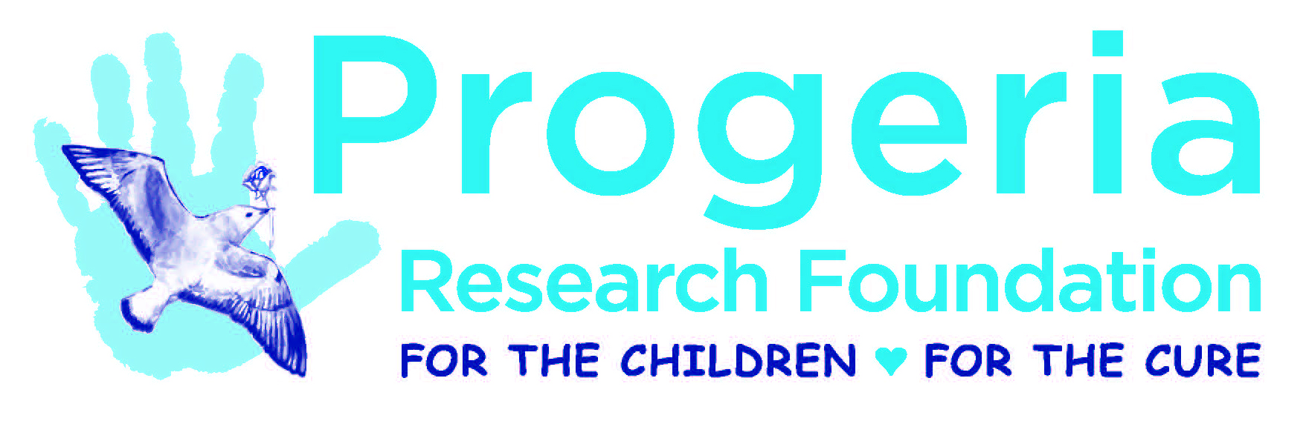

Patent, Intellectual Property, and Technology Transfer Policy
(To be signed along with the PRF Grant Agreement Form after a grant is awarded)

1. The primary purpose of PRF in funding medical research through its research grantees is to support its mission to find the cause, treatment, and cure for Hutchinson-Gilford Progeria Syndrome. PRF recognizes that such research may result in discoveries and inventions that have public health, scientific, business, or commercial value. PRF is interested in supporting and promoting science in the public interest and in making any such valuable discoveries and inventions available for public use as early as reasonably possible. Accordingly, this Patent, Intellectual Property, and Technology Transfer Policy, and any subsequent amendments hereto, are guidelines that shall apply to all discoveries or inventions created through the performance of research supported in whole or in part by a PRF Grant.

2. All inventions or discoveries made in the performance of research supported in whole or in part by a PRF Grant shall be reported in writing to PRF at the earliest practical time, but in no event later than when the invention or discovery is disclosed to the grantee institution where the research was performed (“Institution”).

3. The Principal Investigator of the grant (“PI”) shall promptly notify PRF in writing of any decision to file a patent application or seek an application for any other type of legal protection for intellectual property rights in connection with any discoveries or inventions developed under a PRF Grant. PRF shall keep information regarding such applications confidential, except to the extent that such information is otherwise made public through operation of law or by someone other than PRF, or to the extent that it is necessary for PRF to obtain legal advice regarding such an application. The PI shall notify PRF promptly and in writing of any patent subsequently issued.

4. PRF recognizes that the PI may be subject to certain obligations owed to the Institution or others with respect to research conducted on the Institution’s premises. Notwithstanding such obligations, and, except as provided below, PRF shall abide by the PI’s decision, and/or the Institution’s decision, if applicable, concerning whether to seek a patent or any other legal protection in connection with discoveries or inventions developed under the PRF Grant. However, to the extent that the PI (and/or the Institution, if appropriate) decides not to file a patent application or otherwise seek legal protection for intellectually property rights in connection with discoveries or inventions developed under a PRF Grant, including the decision to abandon any such application, the PI shall notify PRF in writing as soon as possible of such decision, but in any event within such reasonable time frame as would be necessary to preserve all intellectual property rights in any such discoveries or inventions. PRF, at its sole option and at its sole expense, may then decide to file a patent application or seek an application for any other type of legal protection for intellectual property in the U.S. or abroad. In the event that PRF makes such a determination, the PI (and/or Institution, if appropriate) shall assign to PRF, to the extent permitted by law, all right, title, and interest in and to any such discovery or invention and provide all reasonable cooperation and assistance necessary to assign and transfer such rights to PRF. The PI (and/or Institution, if appropriate) shall further provide all reasonable cooperation and assistance to PRF in seeking to obtain and enforcing a patent or other legal protection for intellectual property in the U.S. or abroad.

5. PRF shall share in any monies received from an invention or discovery developed under a PRF Grant. The PI (and/or Institution, if appropriate) shall not enter into any agreement that will derogate PRF’s right to share in such monies and shall notify PRF promptly and in writing of or any license, lease, sale, or other agreement concerning a discovery or invention developed under a PRF Grant that is intended to generate revenue. PRF’s right to share in monies shall include the sharing of licensing fees, royalties, or any other income derived from such invention. PRF’s participation shall be on a pro rata basis, based on PRF’s portion of funding support for the research which led to the discovery or invention. The parties shall work together to develop the details of a reasonable formula. All reasonable administrative and overhead expenses of the Institution, as determined in accordance with the Funding Guidelines and Limitations of the Grant programs of PRF, shall be factored into the calculation of indirect support.

6. In the event that the PI (and/or Institution, if appropriate) grants a license to another party to commercialize an invention developed under a PRF Grant, such license shall include provisions that obligate the licensee to commercialize the invention in a commercially reasonable diligent manner, pursuant to, for example, appropriate diligence requirements and milestones, and the licensor shall monitor performance by the licensee. Unless otherwise agreed with PRF, the PI (and/or Institution, if appropriate) agrees that if it, its designee or licensee has not taken effective steps to arrange for practical or commercial application (e.g., through a license agreement or other reasonable terms) of the invention within three years from the date of issuance of a patent, or another clear determination of commercial value, or such other term that is commercially reasonable under the circumstances, and the Institution or other titleholder cannot show commercially reasonable cause acceptable to PRF why it should retain rights in and title to the invention for any further period of time, then PRF shall have the right to require: (1) assignment of the patent or other intellectual property rights to PRF; (2) cancel any outstanding exclusive license agreement; (3) grant a license under such patent or intellectual property right on terms that are reasonable in the circumstances; and/or (4) any other reasonable disposition of rights in the invention.

7. If the PI (and/or Institution, if appropriate) fails to commercialize any invention or discovery developed under a PRF Grant within a commercially reasonable time, including licensing such invention or discovery to another, and PRF identifies a suitable candidate interested in commercializing such an invention or discovery, the PI (and/or Institution, if appropriate) shall consider such a candidate as a potential licensee and shall license the invention or discovery to such a candidate, provided that the terms of such license are reasonably acceptable to the PI (and/or Institution, if appropriate).

SIGNATURES APPEAR ON THE NEXT PAGE

Signature of Principal Investigator Print Name Date

Address

City, State, Zip Code

Telephone and FAX Numbers

E-Mail Address Award Period From / To Date

Signature of Authorized Representative of Grantee Institution Print Name Date

Title

Address

City, State, Zip Code

Telephone and FAX Numbers

E-Mail Address

Grant Approved by The Progeria Research Foundation

Name: Audrey Gordon, Esq

Title: Executive Director

Signature: _______________________ Date: ______________________________

